Researching the World of Work, Part II

When it comes to researching career options, the internet is a helpful place to start. During this session, students will practice researching occupations using tools available on reputable sites such as O*NET and Bureau of Labor Statistics.

AGENDA
- Warm Up: Reality Check
- Exploring BLS & O*NET
- Break
- ..................Column Break..................Activity: Researching Occupations
- Reflection
- Evaluations

TIPS FOR FACILITATORS
Facilitators should be aware that while some participants who have already identified a few occupational options will find this session helpful, other participants who have not yet narrowed down their options may find it limiting. Additionally, participants who have a very specific occupational focus in mind – like clinical research coordinator – might have difficulty locating the O*NET occupation correlate.
At some point in the lesson, it is important to explain to participants that a) occupations listed on these sites may be called several different names when it comes to job postings/job titles and b) while these sites do have information on hundreds of occupations, they cannot be comprehensive, because new jobs are being created every day, and there are so many variations of jobs even within one occupation.
So, emphasize that the information gathered using these sites is intended as a starting place. To fill in the gaps in information, it will inevitably be necessary to gather more information through real-world interactions with people who do the kinds of work participants are interested in. Additionally, the most important take-away from the session is learning to independently reference these resources (vs. narrowing down occupational options).

WARM-UP
What financial responsibilities do you want to be able to fulfill through work income? What long-term financial goals might you set if you knew you would have a reliable income?
Make the point: Having passions and dreams is a vital part of the career exploration journey. It is also important to clarify your financial needs and wants, and to determine whether your dream pursuit would support them. If not, you may need to find a “just for now job” in order to make ends meet while you pursue longer-term goals, or you may need to identify occupational options that fit your interests and can meet financial needs.
No matter what, in today’s rapidly evolving economy, it is wise to identify multiple options. Your “Plan A” might be your dream job; your “Plan B” might be something in-between; and your “Plan Z” could be a fallback – something you know you can do if your other plans don’t work out.

TOPIC PRESENTATION & DISCUSSION: EXPLORING BLS OCCUPATIONAL OUTLOOK HANDBOOK & O*NET
Review “What is BLS” handout w/ participants. Review “Using BLS” handout. Using your computer and projector, walk participants through the different functions highlighted on the handout.
Once you have oriented participants to the site, engage participants in a “What’s Hot Scavenger Hunt”. Assign each participant a question from the “What’s Hot” handout. Have each answer, have participants share their findings with the group.
Engage participants in reflecting on why certain occupations are quickly growing. For example, the baby boomer generation is aging, so in the upcoming years, there will be more and more available jobs related to elder care.

BREAK

EXPLORING O*NET
Direct participants to turn to the “What is O*NET” page in their packets.

Another career development site developed by the Department of Labor is called O*NET. O*NET is a free, user-friendly resource that provides updated information on hundreds of occupations. O*NET allows you to search occupations by different criteria. These criteria include career clusters (which we discussed last week), green economies, industry, and STEM disciplines. (Review what each of these means and why they may be of interest to participants).

Direct participants to turn to the “Using O*NET” page in their packets. Walk participants through different features using your computer and projector.

ACTIVITY: RESEARCHING OCCUPATIONS
Ask for a volunteer to provide an example of an occupation they are currently interested in learning about. On the large screen, walk participants through filling out the “Occupation Research Table” using information provided on O*NET.
Ask participants to try filling out at least two Occupation Research Tables during group. Provide individual assistance to participants who would like clarification or who need assistance w/ technology.

SUMMARY/REFLECTION
What did you like about these sites? What was challenging? What did you learn/what will you
take away from today’s session?

EVALUATIONS

BLS Occupational Outlook Handbook & O*NET

Today we’ll learn to use reliable, reputable online resources that provide valuable information regarding Labor Market Information – a.k.a. LMI – which is data about the U.S. workforce. LMI includes information like the fastest growing and highest paying industries and occupations. Being equipped with resources that provide this information can help you identify potential occupations or industries of interest, determine whether a certain occupation will meet your financial needs and wants, and help you find out what kind of education, skills, and experience you would need to enter an occupation or industry.

What is the BLS Occupational Outlook Handbook?

The Bureau of Labor Statistics (BLS) online occupational outlook handbook is a government resource that summarizes employment data from across the US. Using the BLS site, you can access labor market information (LMI) such as:

  - Fastest growing industries
  - Highest paying industries
  - Jobs with the newest openings
  - Average salaries across occupations and industries
  - Employment rates across occupations and industries

Why is this Helpful?

Finding out whether an industry or occupation has a promising outlook can serve as a “reality check” when considering which career paths will both match your interests and allow you to meet your financial needs.

Using the BLS Occupational Outlook Handbook

STEP 1: Go to http://www.bls.gov/
STEP 2: Under the “Career Information” header towards the bottom of the page,
click on OCCUPATIONAL OUTLOOK HANDBOOK

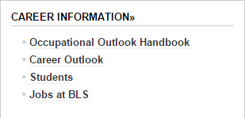

STEP 3: You can either search for occupations selecting specific criteria at the top of the page and clicking GO…
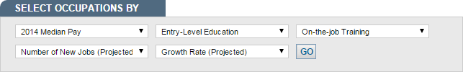

… or you can browse occupations by which are the highest paying, fastest
growing, etc.
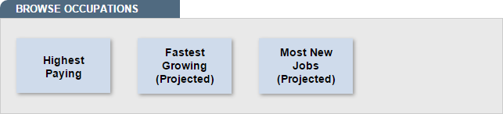

Using BLS (continued)

STEP 5: On the left-hand side, you can also search for specific occupational group to browse occupations in that sector.
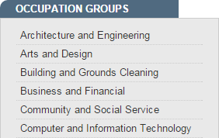

STEP 6: Once you select an occupation you’re interested in, you can browse
information of that occupation via the tabs at the top of the page.

STEP 7: You can view state-specific data by going to the “State and Area Data” tab and clicking on a specific subset of the occupation you selected. You will then be taken to a series of maps representing state-specific data for that occupation.

Activity: What’s Hot?

1. According to BLS, at the national level, which occupation is projected to be the
second fastest growing between 2014 and 2024?
2. Which occupation is projected to offer the newest jobs between 2014 and 2024?
3. On average, what is the highest paying occupation in the “Art & Design” occupation group?
4. Identify an occupation that requires a high school diploma or equivalent and is projected to grow 30% or faster.

O*NET

What is O*NET?

O*NET is a federally-funded job search and exploration tool that contains free, updated information on hundreds of occupations.

What Information Can I Find?

O*NET contains information on individual occupations, including descriptions of the tasks performed, education needed, work activities, job openings, outlook, and more!

You can also search for occupations by category on O*NET. You can browse occupations by:
- Outlook

- Career Clusters

- Green Economics

- Industry
- ..................Column Break..................Job Family

- Job Zone

- STEM Disciplines

Using O*NET

STEP 1: Go to www.onetonline.org

STEP 2: Click on FIND OCCUPATIONS at the top of the page

STEP 3: You can use any of the tools you see to search for occupations, but for now let’s use Career Clusters. Under the “career clusters’ header, select a career cluster you’re interested in exploring and then click GO.
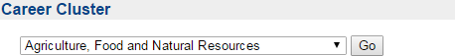

STEP 4: On the next page you’ll see a list of occupations in your selected career
cluster. You’ll also see that some occupations have symbols next to them.
A SUN symbol indicates that the occupation has a bright outlook and is expected to grow rapidly in the next several years.
A GREEN LEAF symbol indicates an occupation that will likely change as a result of the green economy.

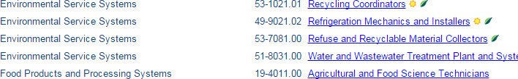

Using O*NET (continued)

STEP 5: Click on an occupation that interests you.

STEP 6: The next page will contain lots of information about the specific tasks, tools, educational requirements, and activities of the occupation you selected.

STEP 7: You can view employment trends and salary information about the specific tasks, tools, educational requirements, and activities of the occupation you selected.
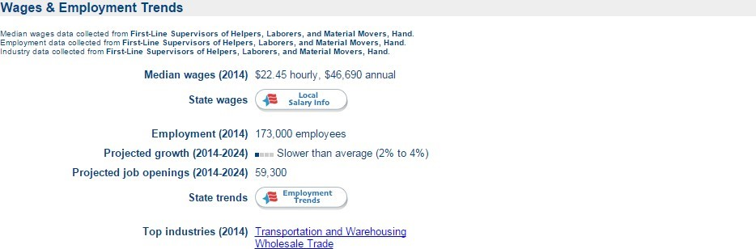

STEP 8: You can view state-specific information by clicking on either the Local Salary Info or Employment Trends buttons, selecting the state you want to look at, and clicking GO.
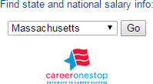

Name of Occupation:
Provide a general description of this occupation. (Hint: Located at the very top of the page.)
List the top 3 skills required for this occupation:
List the top 3 work activities performed in this occupation:
List the top 3 work values that match this occupation. How do these align w/ your top values?
What training/education is required for entering this occupation?
How many years of preparation will this occupation require?
List the top 3 work styles required for this occupation. How would you rate yourself in those areas?
What is the Massachusetts salary range for this occupation? (Hint: Click on “Local Salary Info” button at the bottom of the page).
What is the employment potential for this occupation in Massachusetts? (Hint: Click on “Employment Trends” button at the bottom
of the page).

Name of Occupation:
Provide a general description of this occupation. (Hint: Located at the very top of the page.)
List the top 3 skills required for this occupation:
List the top 3 work activities performed in this occupation:
List the top 3 work values that match this occupation. How do these align w/ your top values?
What training/education is required for entering this occupation?
How many years of preparation will this occupation require?
List the top 3 work styles required for this occupation. How would you rate yourself in those areas?
What is the Massachusetts salary range for this occupation? (Hint: Click on “Local Salary Info” button at the bottom of the page).
What is the employment potential for this occupation in Massachusetts? (Hint: Click on “Employment Trends” button at the bottom
of the page).

Name of Occupation:
Provide a general description of this occupation. (Hint: Located at the very top of the page.)
List the top 3 skills required for this occupation:
List the top 3 work activities performed in this occupation:
List the top 3 work values that match this occupation. How do these align w/ your top values?
What training/education is required for entering this occupation?
How many years of preparation will this occupation require?
List the top 3 work styles required for this occupation. How would you rate yourself in those areas?
What is the Massachusetts salary range for this occupation? (Hint: Click on “Local Salary Info” button at the bottom of the page).
What is the employment potential for this occupation in Massachusetts? (Hint: Click on “Employment Trends” button at the bottom
of the page).

