Researching the World of Work, Part I

For Opening Doors participants, oftentimes, identifying specific occupations too early on in the process feels constricting. On the other hand, some participants have a very specific occupational goal, and may have prematurely eliminated other possibilities. For these participants, this session can help them to expand their options. In both cases, it can be helpful to take a broader view and help participants think about categories (vs. occupations) of interest. One user-friendly solution is to research the world of work using “career clusters.”

TIPS FOR FACILITATORS
  - Some students get stuck around occupational fit – they ask whether there are certain occupations that are a good fit for their diagnoses. (Ex: “I want to find out about jobs that are good for people with ADHD”). Instructors want to emphasize that people’s symptoms/conditions do not need to dictate what they can and cannot choose for a career. However, to set themselves up for success, people do not need to be aware of their strengths and limitations, understand that there are certain soft skills they may need to learn if they want to be successful in a given pursuit, and know where their interests lie.
  - For those in the class interested in becoming entrepreneurs or freelancers, make clear that there are entrepreneurial or self-employment pursuits in every career cluster.

AGENDA
- Orientation to E2
- Topic Presentation & Discussion
- ..................Column Break..................Break
- Activity: Career Cluster Interest Survey
- Evaluations

ORIENTATION TO E2: EXPLORING
What did you want to be when you grew up? When you were a young child, what is one exciting, fantastical, or outlandish career you considered?
(Facilitators might provide an example from their own lives – e.g., singer, astronaut). Have participants share their responses with the group.
Make the connection: Even now, as we’re older and more grounded in the day-to-day realities of life, it’s still important to dream and consider new possibilities. In Module 1, you gave yourselves permission to dream and used your vision to construct a vocational profile. This vision is meant to serve as your compass as you identify and consider vocational choices.

Now that you have your compass, you need your map. Where are you going, and how will you get there? Module 2 of Opening Doors is focused on helping you answer these questions.

TOPIC PRESENTATION & DISCUSSION

We said that Module 2 is about creating YOUR map. But where to begin? There are over 800 catalogued occupations! But as you explore the idea of reentering the world of work, it is oftentimes not possible or desirable to target a specific occupation right away. Instead, it can be helpful to first identify categories of occupations that match your interests. We call these categories “Career Clusters”.

Direct participants to navigate to the CAREERwise Education Career Clusters page. Explain the Career Clusters Diagram.

https://www.careerwise.mnscu.edu/careers/aboutclusters.html

To help people make informed career decisions, the US Department of Labor (DOL) has created the “Career Cluster” classification system. (For those that don’t know, the DOL is a department of the federal government that is responsible for developing programs related to many aspects of work). This graphic, created by Minnesota State, depicts this career cluster system. While there are hundreds of documented occupations, there are just 16 career clusters.

Looking at this diagram – do any fields immediately stand out to you? How about clusters within those fields? Based on your RIASEC profile, which clusters do you think might be a good match?

Using someone’s response, demo navigating to a cluster description and reviewing the
description.

Show participants how to read a career cluster profile. Make sure to emphasize the
“exploratory activities” listed at the bottom of each cluster overview page. This is information
students can put in their research summaries.

Navigate to the sample pathway page “Recreation, Amusements, and Attractions.” Explain
the concept of pathways and the graphic. https://www.careerwise.mnscu.edu/careers/recreation-amusements-pathway.html
Clusters correspond to interests, so for example, a person interested in socially-oriented activities and settings might be drawn to the Hospitality and Tourism cluster. Within that cluster, there are four related but distinct pathways – Lodging; Recreation, Amusements, and Attractions; Restaurants and Food and Beverage Services; and Travel and Tourism.

Explain to participants how the image is organized by duration of training. Mention how to click on links to specific occupations.

Transition to Activity

Our goal today is to help everyone identify three or four career pathways that they would like to investigate. In order to do this, you’ll take an online test that will indicate which clusters might be a good match for your interests. From there, you’ll be able to focus your research through identifying career pathways of interest.
ACTIVITY: Career Clusters Interest Survey https://careerwise.minnstate.edu/careers/clusterSurvey

  - Using your computer and projector, demonstrate how to navigate to and complete the Career Cluster Interest Survey. Instructors may also want to complete a survey ahead of time so that they can have a results page ready to display to the class. Allow time for participants to complete survey.
  - Once participants have finished the survey, show them how to navigate to the cluster overviews and pathway maps from their results.
  - Explain how to complete the Career Research Summary, which can be started in class and completed over the course of Module 2.

SUMMARY/REFLECTION
What did you learn today? What exploratory activities are you considering? What research questions did you generate?

Career Clusters
What are Career Clusters?
To make occupational research easier, the Department of Labor has categorized thousands of occupations into 16 Career Clusters based on interests.

The 16 Career Clusters
Health Science  Education and Training  Architecture and Construction  Human Services  Science, Technology, Engineering and Mathematics  Hospitality and Tourism  Law, Public Safety, Corrections, and Security  Agriculture, Food and Natural Resources | Arts, Audio/Visual Technology and Communications  Business Management and Administration  Government and Public Administration  Information Technology  Manufacturing  Marketing  Transportation, Distribution, and Logistics  Finance

More on Career Clusters
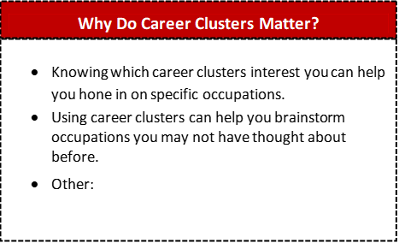

Example Cluster Research Summary
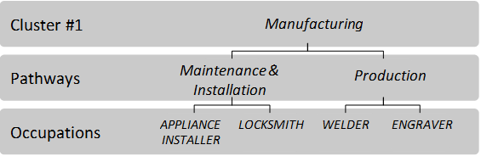

Exploratory Activities
(ways to find out more about these jobs)
.Job shadow a locksmith
Research apprenticeship opportunities online Visit an auto shop
Interview an engraver

Research Questions & Notes
(important information & questions)
Involves working with machines.

Could be outdoors, in people’s homes, or in a factory.

What does the training entail?

What schools offer training and certificates that I would need?

How much stress is involved in each of these occupations?

What are the job prospects?

Which of these would allow me to be self-employed?

How do I set up a job shadowing opportunity?

Cluster Research Summary
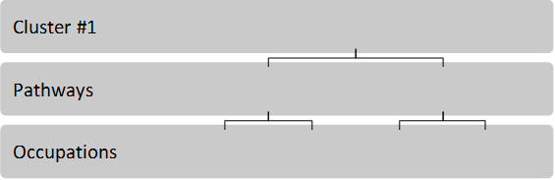

Exploratory Activities

Research Questions & Notes

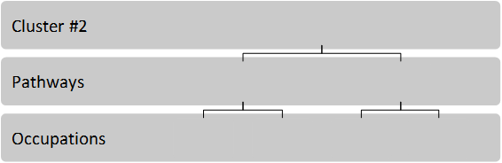

Exploratory Activities

Research Questions & Notes

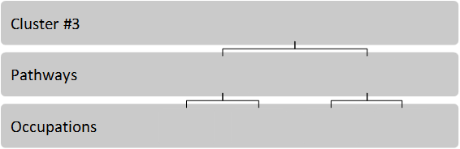

Exploratory Activities

Research Questions & Notes

