8: Identifying My Interests

OVERVIEW
The purpose of today’s session is to help students answer the question “What are your interests?” using multiple approaches. Students will create a picture of a work setting that would be a good fit for who they are/who they want to become. Students will also get some initial ideas regarding occupations that fit their interest profiles.

AGENDA
- Warm Up
- Activity I
- Break
- Activity II
- Reflection
- Evaluations

WARM-UP & DISCUSSION
Share quote. (See PowerPoint) “I think the big mistake in schools is trying to teach children anything, and by using fear as the basic motivation. Fear of getting failing grades, fear of not staying with your class, etc. Interests can produce learning on a scale compared to fear as a nuclear explosion to a firecracker.” – Stanley Kubrick
Elicit comments from a few participants. What does this quote mean to you? Can you recall a time when you were so interested in something that you dedicated extra time and energy to working on it? How does that compare to work that you were obligated to do but not interested in? Based on this statement, why might it be worthwhile to spend time identifying our career interests?
Make the point: our interests are the key to our own internal motivation. Finding work that engages our interests improves our chances of success and satisfaction.
Review Holland Interest Type briefly (see PowerPoint). Explain to students that today we will be engaging in a variety of activities designed to help them discover their three-letter RIASEC codes, which can later be matched to specific occupations.

BREAK

ACTIVITY OPTIONS
  - “Where I Like to Be” (handout). Review instructions with students. Allow 10-15 minutes for students to work individually. Provide 1:1 help as needed. Comeback together as a group and discuss. Who is willing to share their “Where I Like to Be” statement? Do you feel this is an accurate representation of yourself? Did anything surprise you about this exercise? What aspects came naturally? What was challenging?
  - “O*NET Interest Profiler” (handout). Review instructions with students. Allow 10-15 minutes for students to work individually. Provide 1:1 help as needed. Come back together as a group and discuss. Ask: “What was your highest scoring area of interest? What are some of the occupations associated with your interest profile? Do you feel like these are a match for you? Why or why not?”

SUMMARY/REFLECTION

What did you learn about yourself today? How can you use your learning moving forward?

AT HOME
My Career Story. Explain to participants that next class will be the final session of Module 1. To conclude the module, you are asking them to create a summary of their leanings that they can share with the class. They can do this either through writing a short narrative or creating a vision board. Provide students with examples of both. Distribute poster board.

EVALUATIONS

Identifying My Interests

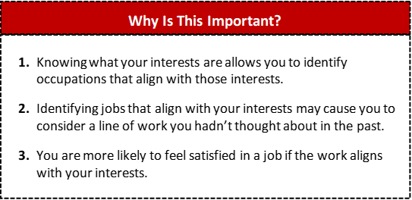

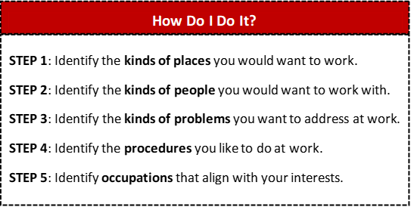

Activity: Interest Profiler

What is the Holland Interest Profiler?

The Holland Interest Profiler classifies your interests according to six
different categories of occupations to determine which lines of work might best suit you.

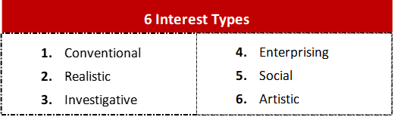

What is O*Net?

O*NET is a free service/site developed by the US Department of Labor. It includes a variety of tools that can help inform your career exploration process. The O*NET Interest Profiler is a 60-question survey that will help you determine your RIASEC code.
Link to O*NET Interest Profiler: https://www.mynextmove.org/explore/ip

My Primary Interest Area: My Secondary Interest Areas: My RIASEC Code:

Occupations that Match My Code
https://www.onetonline.org/find/descriptor/browse/Interests/

